Hello PDC!
On February 4th, we held our 2nd pre-dental club general meeting wherein we hosted D2’s: Aziz Susarrey, Mario Endiakov, and John Tran from the UIC College of Dentistry to talk about scholarships available for dental school. They talked about scholarship programs through the Navy, the Air Force, and NHSC (National Health Service Corps) respectively. Listed below is the information that was discussed.
-Ira Delos Reyes
Secretary of Pre-Dental Club at UIC

Scholarships in Dental School

Why consider scholarship?
For UIC College of Dentistry, tuition for the D1 year cost around $47,000 and cost $70,000 for your D2-D4 year. Every year, tuition goes up by 3%. Loans such as federal unsubsidized and Grad PLUS accrue interested while your in school. The interest for those loans is 5.84%
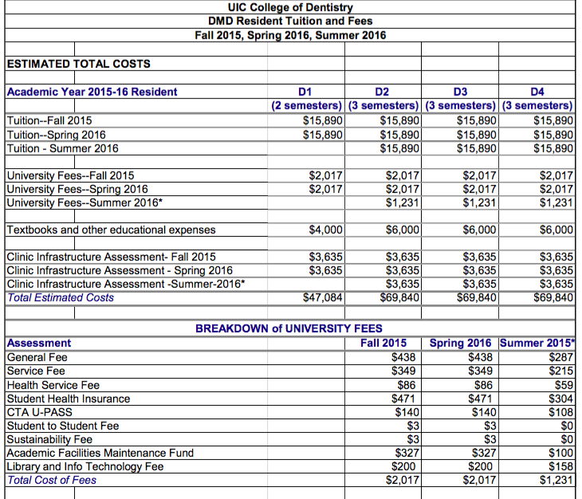

What are your options?
- HPSP (Health Professions Scholarship Program)
  - Army
  - Navy
    - Tuition: paid for
    - Monthly stipend: >$2,000/month
    - Sign-on bonus: $20,000
    - Specialization: AEGD/GPR, Orthodontics, Endodontics, Periodontics, Prosths, OMFS, etc
    - Contract requirement: Active duty one year for every year of participation
  - Air Force
    - Tuition: paid for
    - Monthly stipend: <$2,000
    - Sign-on bonus: none
    - Specialization: AEGD/GPR, Orthodontics, Endodontics, Periodontics, Prosths, OMFS,
    - Contract requirement: Active duty one year for every year of participation. Total of 7 years (reserve for the remainder)
- NHSC (National Health Service Corps)
  - Tuition: Paid for
  - Monthly stipend: $1,300/month + yearly ORC (other reasonable cost)
  - Sign-on bonus: None
  - Specialization: Pediatric Dentistry, Public Health Dentistry, AEGD/GPR
  - Contract requirement: same number of year of taking out the scholarship, minimum of 2 years. Work in underserved communities at a site with a minimum HPSA score

How can you prepare?
All of these scholarships are very competitive because you are competing against other dental students nationally. What you can do is have a competitive GPA. It should be higher than average matriculation GPA. You should have expressed motivation to serve for long term through personal statement and interview. Have great letters of recommendations/reference from people who really know you well.

Q & A with D2’s

What were you asked during your interview for the scholarship?
How was your undergrad experience? Why do you want to do this? (This is an important question they want to know) Why would you be fit to be here? Why do you feel qualified? They will ask you about your courses in undergrad and your DAT scores. As long as you’re genuine and not just in it for the benefits, you should be able to do well. Think about these questions as your writing your essay also.

Do you have to go through basic training when you go on the base?
You have to go through one month of officer training. You’ll learn how to salute and things like that. You don’t do any hard training.

How soon after you graduate do you start?
You can start working after you get your license.

What is the starting salary after graduation?
You start with around 70K with added benefits. Your salary goes up every year because your rank goes up as well.

What is required of you when you’re in dental school and you got the scholarships?
You would have to send the military health updates every year and your board exam score. Your lifestyle is basically like a civilian while you’re still in dental school. They want you to focus on school. There’s not many requirements besides keeping them updated with your grades and your health.

How is the lifestyle like after graduation and when you’re working on base?
You work as a dentist 5 days a week from 7am-4pm. You are free to go on the weekends, depending on where you’re placed. If you’re married, you can bring your partner with you. They will also get benefits. You don’t have to live on base either. When you start working, you don’t need to worry about materials, mal practice, or rent. The military covers all of that. All you need to worry about is making your patients happy. No worries about finances

Can you apply while you’re in dental school or is it only before?
It depends on the deadline. We applied for the 4 year scholarship, so we applied before starting dental school. There’s also a 3 year scholarship that you can apply to during your D1 year. But apply as soon as possible. For the 4 year scholarship, apply for both the scholarship and for dental school. They will only take you after you’ve been accepted to dental school.

General advise from the D2’s
-You might not want to do this program if you want to specialize because you’d have to go back to school for 2-3 years after serving in the military after you graduate.
-Keep in mind that for dental school applications, you need at least one letter of recommendation from a science professor. Most dental schools require letters from two science professors. So start sucking up
-Recommend living on campus for your first year in dental schoo. Commuting isn’t for everybody.

For additional resources, please visit:
http://www.uicasda.com/financing-a-dental-education.html

