Hi PDCer’s,
Thanks to everyone who came to UIC College of Dentistry’s admission presentation this past Wednesday, September 27th. During this presentation we got to hear about requirements and advice from the Directors of Admissions at the college, Carolyn Feller and Braulia Espinosa. Below are some key points, and like always if you have any questions feel free to send us an email at uicpdc32@gmail.com
- UIC College of Dentistry; located in one of the largest medical districts in the world, the college offers the following programs.
- DMD (Doctor of Dental Medicine) program
- DMD/PhD program (7 years)
- MDM-MS in Clinical Research (5 years)
- Post Graduate Specialty Programs
- Endodontics
- Oral Surgery
- Orthodontics
- Pediatric Dentistry
- Periodontics
- Prosthodontics
Being in the heart of the city of Chicago and only a couple miles from the loop, UIC COD students are able to have lot of clinical experience as well as possible research opportunities since the college is a level-1 research institution.
- What are admission requirements for UIC College of Dentistry?
  - A Baccalaureate Degree is required
  - All course credits must be from an accredited United States college or university:
    - Required courses:
      - Chemistry: 14 semester hours with at least 4 semester credits in Organic Chemistry
      - Biological Sciences: 6 semester hours
      - Physics: 6 semester hours
      - English: 6 semester hours
      - *Biochemistry is a new requirement at UIC*
    - All required prerequisite courses taken must be a grade of “C’ or better
    - Advanced Placement (AP) courses are not accepted as course requirement
  - Dental Admission Test (DAT): It is strongly suggested that applicants complete this test prior to the year they wish to enter school
  - Letters of Recommendation: Three letters of recommendations are required. One committee letter will satisfy the three-letter requirement. It is strongly recommended that two references come from science professors and one from a dentist you have shadowed
Residency Requirement: To be eligible for admissions to the DMD program, candidates must hold United States citizenship, permanent residency or Asylee status
- What’s the application process?
  - AADSAS: June-December
  - UIC COD Application Deadline: November 15th
  - Applications are reviewed: August-February
  - Interviews: September-February
  - Admission Decisions: December-April

- What makes me competitive for UIC?
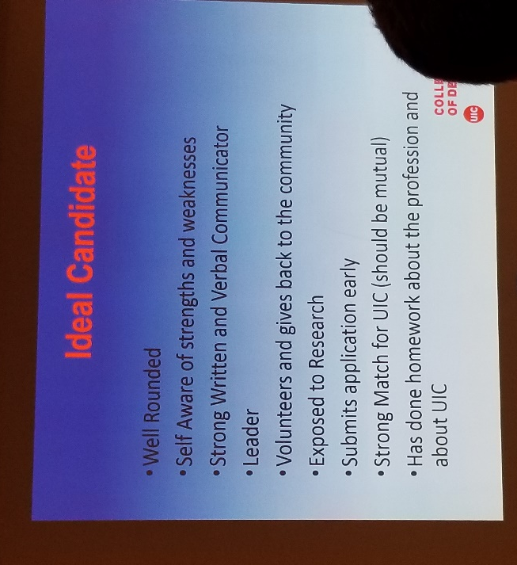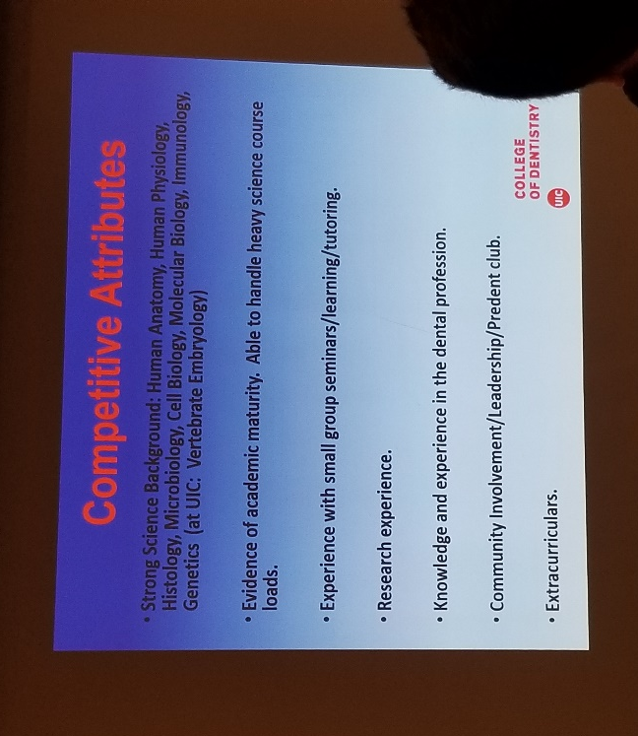
For more information Braulia and Carolyn can be contacted at the following email addresses
Braulia Espinosa: bespin1@uic.edu
Carolyn Feller: cfeller@uic.edu
UIC College of Dentistry website: http://dentistry.uic.edu/

- Next Meeting;
When? Wednesday, October 4th at 5:00pm
Where? BH 316
What? for this meeting we’ll be splitting into groups to discuss different aspects of the pre-dental student process
- Other events;
  - Don’t forget the Chicago marathon is this SUNDAY, 10/8. If you’re volunteering with us look out for an email regarding meeting times since we will be traveling as a group.
  - UIC College of Dentistry will be having an event at 4:30pm on 10/16 lead by the dental students. This is a hands-on waxing exercise to work on your manual dexterity skills! Sign up at this link https://goo.gl/forms/LAPWonyBtY1KyBWK2

Additionally, member dues are now being collected. Deadline for dues is Friday, October 27th by 4:30pm. Dues ($25 – two semester option OR $15 – one semester option) are to be paid to the treasurer, Bob.

