Hello PDC!
On November 2nd, 2016, we had a meeting with a Navy representative that talked about the Health Profession Scholarship Program (HPSP). The purpose of this meeting was to help undergraduate pre-dental students find a way to pay for dental school. This information below is just a rough guideline to make sure you have an idea of what the Navy will be like, which is not bad AT ALL! I recommend considering it!
Reason to consider the Navy or other scholarships! Here is the price of schooling from Fall 2015 D1-D4 year.
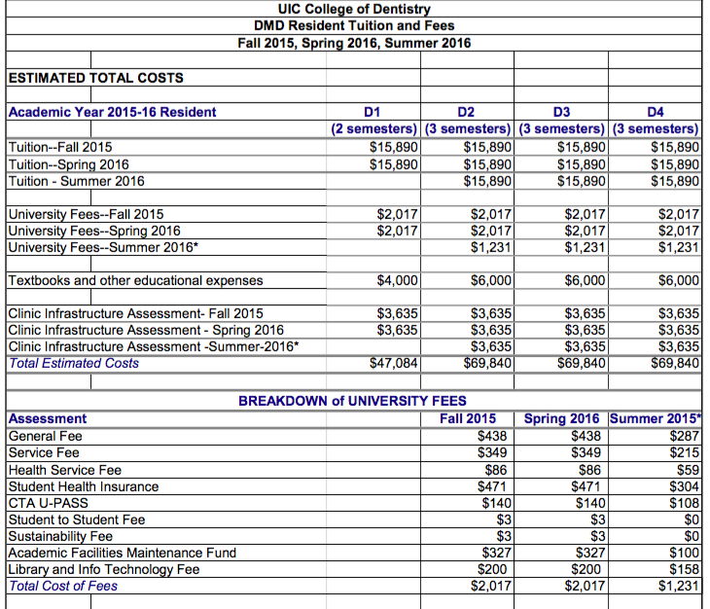

If you get accepted into their program, you get the following:
- Tuition paid for in FULL (even equipment and parking)
- Monthly stipend of about $2,200
- Sign-on bonus of about $20,000
What they expect: The only thing they ask in return is 3 years of service stationed wherever the location sounds most fitting for you right after you finish your 4 years of whichever dental school you want. During those 3 years, you help the less fortunate most the time, start as a LT or an O3, and make 64-85 thousand a year. After that is done you can stay in the Navy, or have your own dental practice.
For more information visit Navy.com and text “interested” to (630)-936-9809.

